***OOP Project G046-BG***

***Violation System.***

***Dr\ Sherin Moussa.***

***Dr\ Sally Saad.***

***TA\ Alshimaa Mohamed.***

* ***Team Members:-***
* ***2016170124 – Bassem Maher Ramadan –Section 5***
* ***2017170338 – Mohamed Samir Asaad -Section 13***
* ***2017170116 – Tawfek Hesham Tawfek –Section 5***
* ***2017170198 – Shrook Ehab Attia -Section 5***
* ***2016170528 – Khadija Essa Abdallah -Section 6***
* ***System Definition:-***

***A Non-automated System which detect violation Buildings.***

* ***System Objectives:-***

***Obtains a valid & verified System that keep data about various Buildings’ information and allows to take a serious actions towards violation buildings.***

* ***User Requirements:-***
* ***The Users of this system is divided into four types:-***

1. ***Admin of the system.***
2. ***Inspector.***
3. ***Head of Hearing Committee.***
4. ***Hearing Committee Members.***

* ***Each User has a specific interface with different functionalities:-***

1. ***Admin :-***

* ***Add Users of the system and assign them to their jobs.***
* ***Delete Users.***
* ***View Users and View Current Violations, Appointment Violations and Finished Violations.***

1. ***Inspector :-***

* ***Add Or Edit Or Delete Current Violations.***
* ***View Current Violations, Appointment Violations and Finished Violations.***

1. ***Head :-***

* ***View Current Violations, Appointment Violations and Finished Violations.***
* ***Add a specific Appointment for a specific violation.***
* ***Add Validation for a specific Violation (Whether it has been judged or not).***

1. ***Member :-***

* ***View Current Violations, Appointment Violations and Finished Violations.***
* ***Transfer the Violations that has time to the Appointment List.***
* ***Transfer the Appointment Violations that have been judged to the Finished Violations List.***
* ***System Requirements:-***

1. ***Software Tool Used:-***

***NetBeans 8.0.2***

1. ***Programming Language Used is Java Swing GUI and “JTattoo” Look And Feel.***
2. ***Using Text Files to store the System’s Data.***
3. ***Software Tool Used to draw the system’s Flowchart :-***

***Microsoft Visio Professional 2013.***

1. ***Software Tool Used to draw the UML Diagram of the System classes :-***

***NetBeans 8.0.2 and attach the Plugin “EasyUML” that have Extension “.nbm” .***

1. ***All Unexpected Exceptions are Handled.***
2. ***Each User Has Unique ID, Username, Password and his job.***
3. ***Each Violation Has Unique ID, Name, Address, Complain and its Photo Attached to it.***

***UML Diagram***

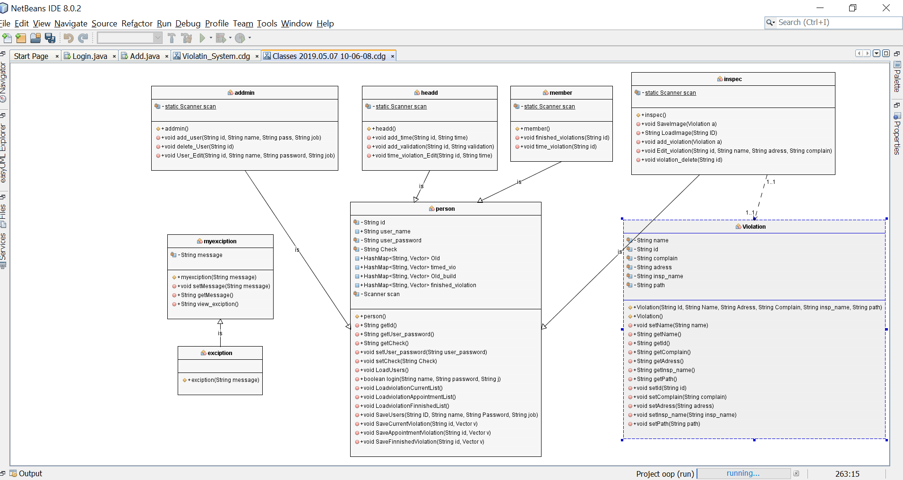

***Flowchart***

